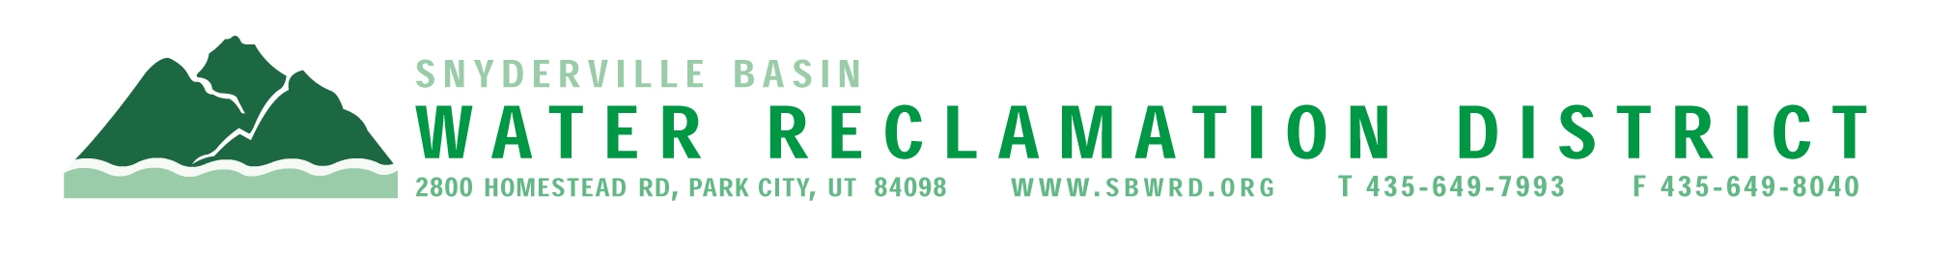

CONTACT: Michael Luers
FOR IMMEDIATE RELEASE (435) 649-7993, ext 223
mluers@sbwrd.org

SNYDERVILLE BASIN WATER RECLAMATION DISTRICT RECEIVES
2012 PLATINUM PEAK PERFORMANCE AWARDS

PARK CITY, UTAH (August 2013) – The Snyderville Basin Water Reclamation District (SBWRD) recently received two National Environmental Achievement Awards at the platinum level for its operational performance. The Platinum Peak Performance Awards were presented by the National Association of Clean Water Agencies (NACWA) and recognizes SBWRD’s accomplishments and contributions for operating environmentally friendly reclamation facilities multiple years in a row.

The SBWRD received the Platinum Awards for its two facilities. The East Canyon Water Reclamation Facility has achieved 100% compliance with its treatment requirements for nine consecutive years, while the Silver Creek Water Reclamation Facility has achieved 100% compliance for ten consecutive years.

“Our goal at the Snyderville Basin Water Reclamation District is to protect human health and to protect our local environment,” said Michael Luers, General Manager at SBWRD. “We are honored to be recognized for our commitment to the Snyderville Basin/Park City community.”

The SBWRD’s awards and facilities were recognized at a July 16th awards ceremony at NACWA’s Annual Conference in Cincinnati Ohio. The SBWRD facilities are also featured in the organization’s August/September issue of Clean Water Advocate.

For more information on Snyderville Basin Water Reclamation District’s water quality efforts, please contact Michael Luers, General Manager, or visit us at www.SBWRD.org. National Environmental Achievement awards are sponsored by the National Association of Clean Water Agencies in Washington, DC.

#####

